1: Decision Support Systems (DSS)
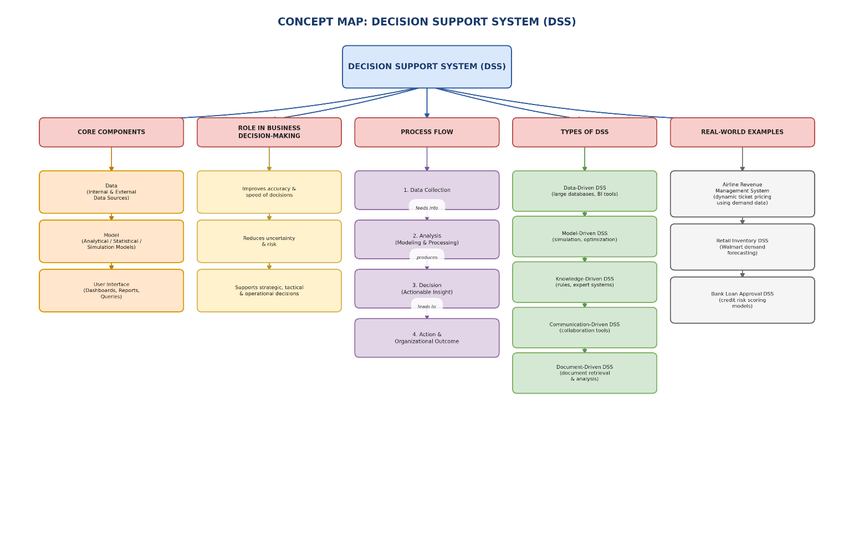
2: Operational Systems vs DSS 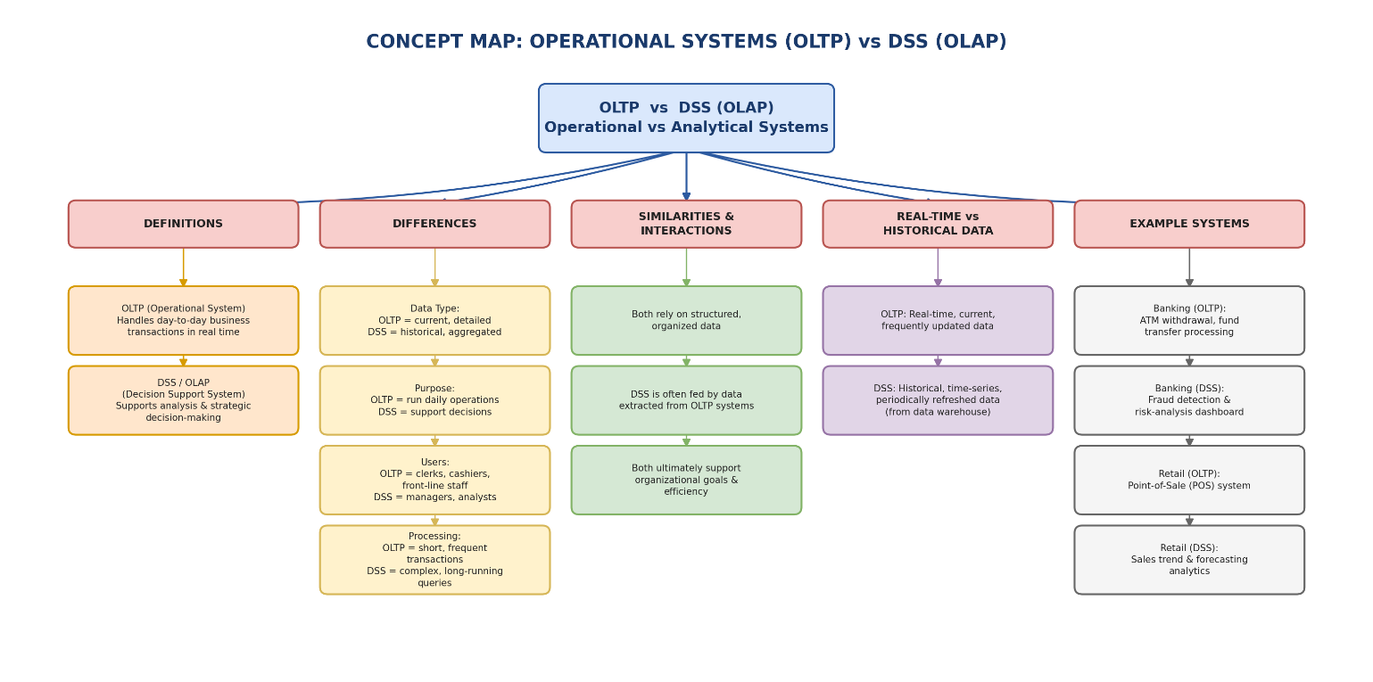

3: Architecture of Data Warehouse 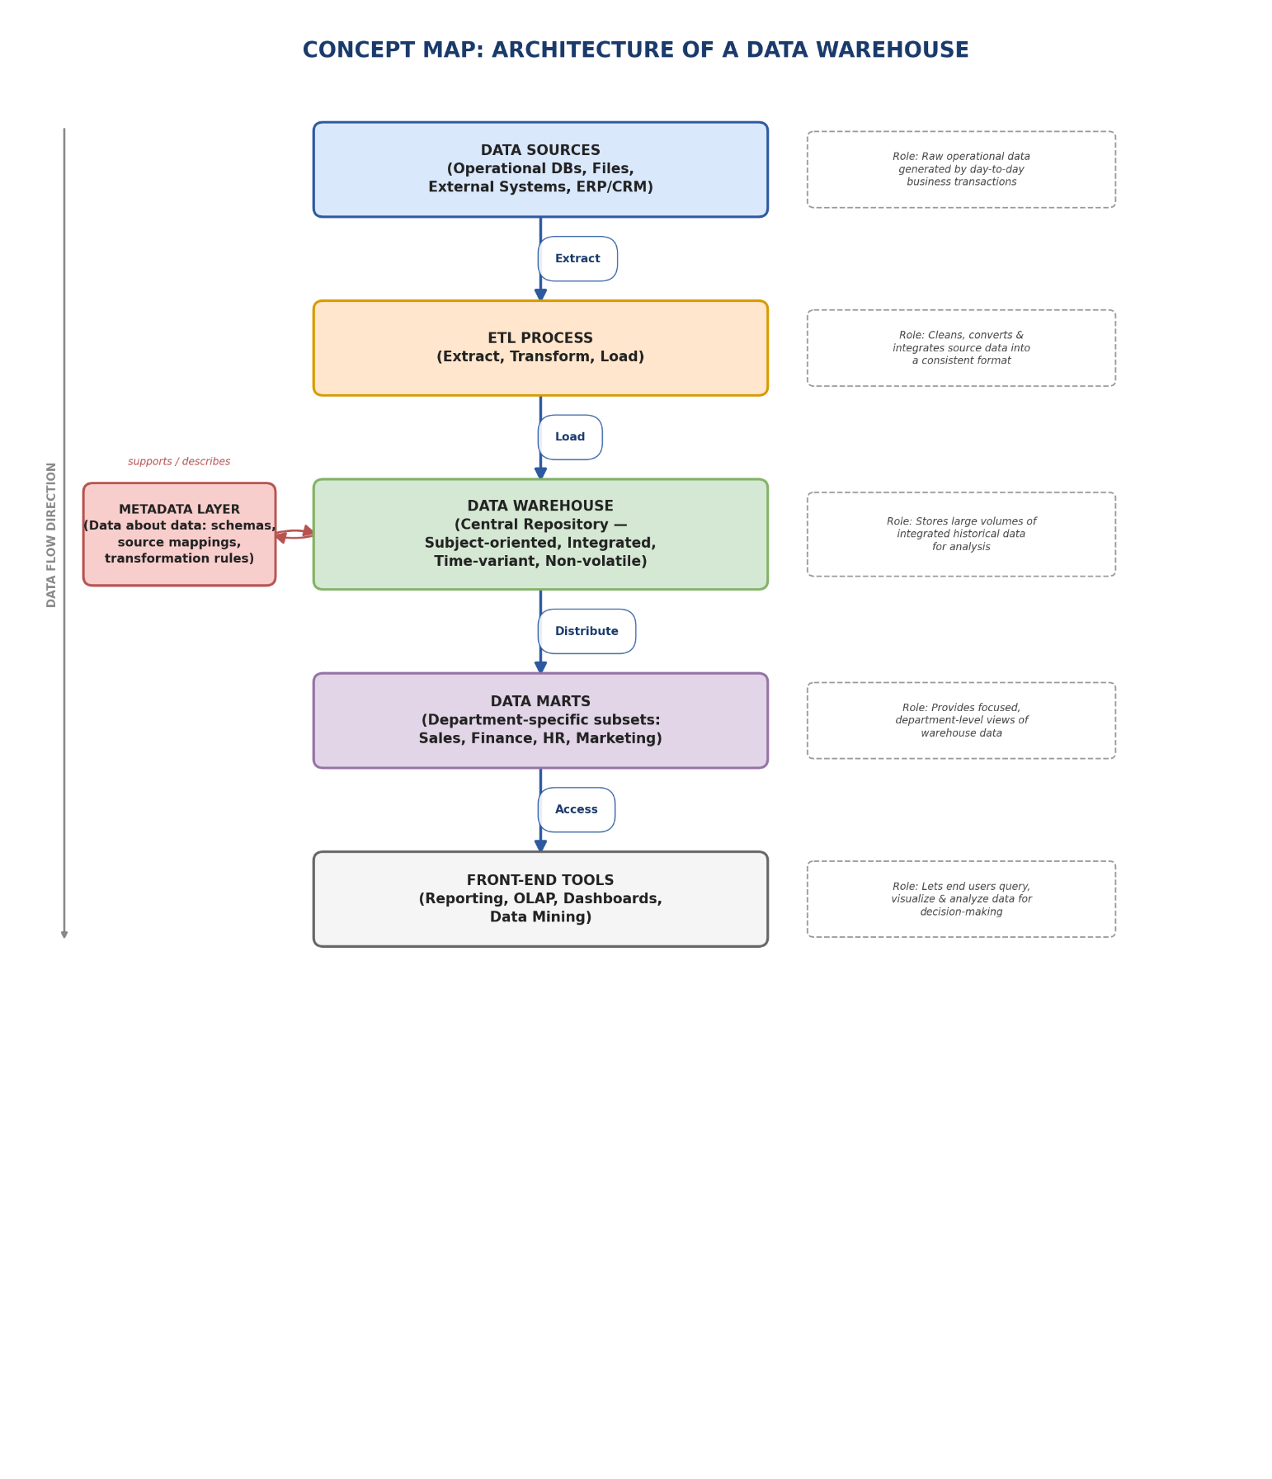

4: OLAP, Data Cubes & Dimensional Modelling 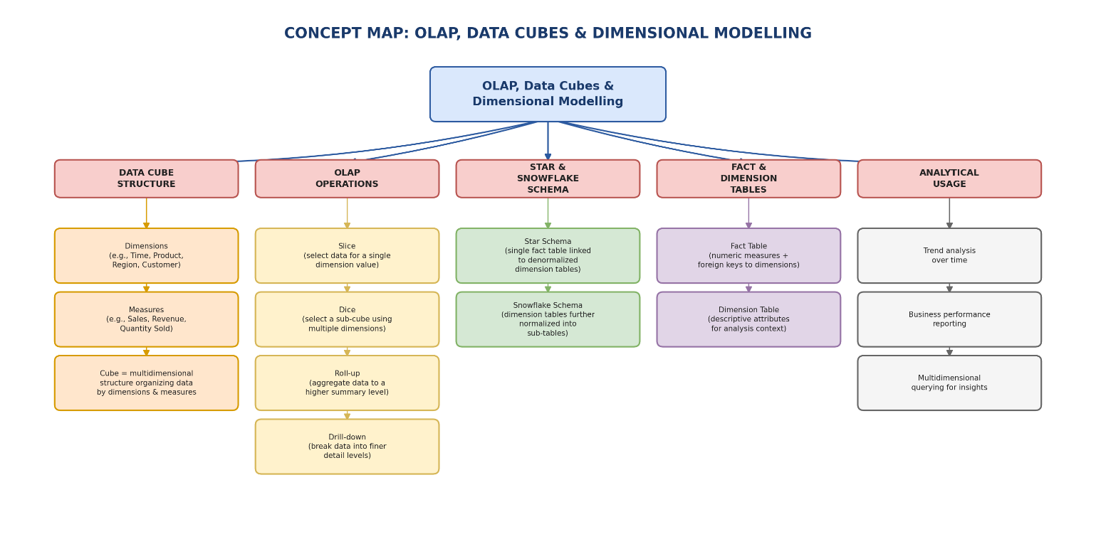
5: Query Processing & BI Tools (KNIME)